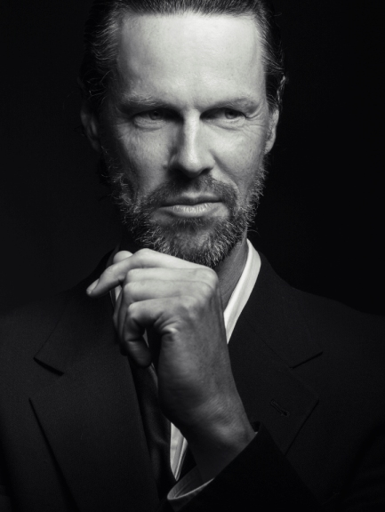

“Bass-baritone Paul Whelan deftly colored his lines with rich darkness and foreboding intensity”
Times-Union, Timothy Tuller,
2 June 2018

“Paul Whelan, bass, demonstrates that one can appear in a single scene and still steal the show. His aria as Prince Gremin (“All men surrender to Love’s power”) is sweet and tender, while his bass notes are strong and resonant.”
KC Metropolis, Anthony Rodgers,
1 October 2017

Paul Whelan begins the 2018-19 season at Opera New Orleans in the role of Timur Turandot. He travels to Scottish opera for the world premiere of Stuart MacRae’s opera Anthropocene in the role of Captain Ross. At Garsington Opera the artist sings the role of Commendatore Don Giovanni

Last season, Paul Whelan made his house debut at Lyric Opera of Kansas City in the role of Gremin Eugene Onegin winning outstanding reviews. In Norway he performed Haydn Creation with the Norwegian Arctic Philharmonic Orchestra before returning to US to sing the role of Hagen in selections from Götterdämmerung with the Jacksonville Symphony.

In recent seasons, bass-baritone Paul Whelan stepped into the roles of Nettuno, Tempo and Antinoo Il ritorno d'Ulisse in patria at The Grange Festival for which he received enthusiastic reviews. He recently added the role of Sarastro Die Zauberflöte to his repertoire which he sang at Hawaii Opera Theatre; in Geneva he joined the Grand Theatre for their new production of A Midsummer Night’s Dream as Quince, and he appeared at Gothenburg Opera for the role of Claudio Hamlet in a new production by Stephen Langridge for which he won sterling reviews.

Recent highlights include the role of Daland Der fliegende Holländer at Hawaii Opera Theatre and New Zealand Opera, Giorgio I Puritani at Boston Lyric Opera and Victorian Opera, and his role debuts as Nick Shadow The Rake’s Progress for Opera New Zealand, Banco Macbeth at Opera North in the UK, and Titurel Parsifal with the City of Birmingham Symphony Orchestra under Andris Nelsons.

Other past successes include the artist’s return to Opera Australia as Ramfis Aida, and an appearance at Grant Park Music Festival in Chicago for Beethoven's Mass in C. He sang Jesus in fully staged performances of St. Matthew Passion in Brisbane, and appeared as Seneca in a new production of L'Incoronazione di Poppea in Lille and Dijon. Other notable appearances include Theseus in the new production of A Midsummer Night's Dream for English National Opera, Collatinus The Rape of Lucretia for Opera Norway as well as Bach’s St. Matthew Passion for the Leeds International Concert Season. Additionally, he appeared at Glyndebourne in two other roles: Claggart in their new production of Billy Budd, and Alidoro La Cenerentola. He sang his first Wotan in Das Rheingold with the Auckland Philharmonic to critical acclaim.

Significant appearances include the title role in Bluebeard's Castle with NBR Opera New Zealand; Four Villains Les Contes d'Hoffmann at Southern Opera; Argante in Handel's Rinaldo in Munich; Apollon in Gluck's Alceste at the Dresden Festival; a staged production of Bach's St. John Passion

(directed by Deborah Warner), Schaunard in a new production of Leoncavallo's La bohéme, Raimondo Lucia di Lammermoor all at English National Opera; Escamillo Carmen at Welsh National Opera; and Harry Joy Bliss at Hamburg State Opera and world premieres of The Assassin Tree by Stuart MacRae in a joint production with the Royal Opera House and the Edinburgh Festival, and Bird of Night by Dominique Legendre, also for the Royal Opera House, Covent Garden.

Concert appearances include Stanford's Songs of the Fleet with Ulster Orchestra, Mountararat in Gilbert and Sullivan's Iolanthe with San Francisco Symphony, The Dream of Gerontius (Priest and Angel of Agony) which he sang at Grant Park Music Festival in Chicago, in Berlin, Salisbury and in New Zealand; the bass soloist in Mozart's Coronation Mass with Eugene Symphony Orchestra; a return to the London Bach Choir for St. Matthew’s Passion at the Festival Hall; the world premiere of Terra Incognita, a symphonic cantata for bass soloist and choir written for the artist by Gareth Farr and performed by the New Zealand Symphony Orchestra.

Other orchestral engagements include St. Matthew Passion with the City of Birmingham Symphony Orchestra and London Bach Choir, Judas The Apostles at Leeds Festival, Mussorgsky's Songs and Dances of Death with the Ulster Orchestra recorded for BBC Radio 3; Walton's Belshazzar's Feast with the Orquesta Sinfonica de Madrid (broadcast live), a series of concerts with Sir Charles Mackerras and the Sydney Symphony Orchestra; Schoenberg's Gurrelieder at the Bolshoi Theatre in Moscow, Delius's Sea Drift in Osaka, Valens in Handel's Theodora with Scottish Chamber Orchestra, also presented in Winterthur, Switzerland.

Paul is a winner of the Cardiff Singer of the World Lieder Prize. Conductors with whom he has collaborated include Sir Simon Rattle, Kent Nagano, Richard Hickox, Yehudi Menuhin, Valery Gergiev, Gary Bertini, and Vassily Sinaisky; he has given recitals at Wigmore Hall, The Purcell Room, Cardiff’s St David's Hall, Cheltenham Festival, BBC Pebble Mill, Perth Festival and at the Chátelet Theatre in Paris. Recordings include A Midsummer Night's Dream with the London Symphony Orchestra under Sir Colin Davis (Philips), Kurt Weill's Silber See under Markus Stenz (BMG); recordings with the BBC Philharmonic for Chandos and with the BBC Scottish Symphony for Hyperion..

Artist Manager: Deborah Sanders
deborah.sanders@rayfieldallied.com
Biography valid until September 2019
For updated versions please contact
nathan.murphy@rayfieldallied.com

